**WebstaurantStore Code Screen Task**

**Performance Test Report**

**Load Test Details:**

Test Plan: WebstaurantStoreS&D

Test Date: July 10, 2023

Test Start: 9:26 PM EST

End Time: 9:41 PM EST

Duration: 15 minutes

PT Tool: Apache JMeter

Script Flow

The document below contains the script flow used to build JMeter test plan.



Performance Test Metrics

The document below contains the performance metrics to measure the performance of the 15 minutes load test execution.



HTML Report from JMeter



**Transaction Throughput and Response Time Summary**

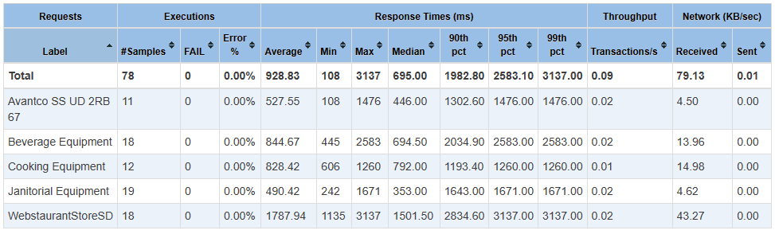

**Transactional Throughput:**

|  |  |  |  |
| --- | --- | --- | --- |
| Transaction Name | Transactions Per Sec | Transactions Per Min Achieved | Expected |
| Avantco SS UD 2RB 67 | 0.02 | 1.2 |  |
| Beverage Equipment | 0.02 | 1.2 |  |
| Cooking Equipment | 0.01 | 0.6 |  |
| Janitorial Equipment | 0.02 | 1.2 |  |
| WebstaurantStoreSD | 0.02 | 1.2 |  |
|  | Transactions Per Min | 5.4 | 5 |
|  | Transactions over 15 min | 81 | 75 |

**Note:**

Throughput calculation includes the user ramp-up time.

Test achieved the Transactional Throughput expectations.

**Transaction Response time:**

95 percentile transaction response time for all transactions except the “WebstaurantStoreSD” transaction was less than 3 seconds. 95 percentile response time of 3.137 seconds for the “WebstaurantStoreSD” transaction did not meet the assumed SLA of 3 seconds or less.

Min, Max response time variation needs to be investigated further by understanding the standard deviation.

**Errors/Transaction Failures:**

Test did not encounter any errors/transaction failures.

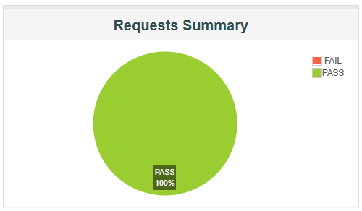

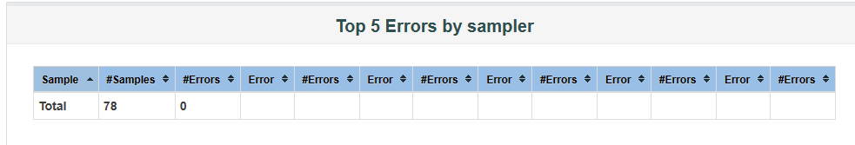

**Active Threads over time**

Thread maintained a user concurrency of 4 to achieve the target throughput.

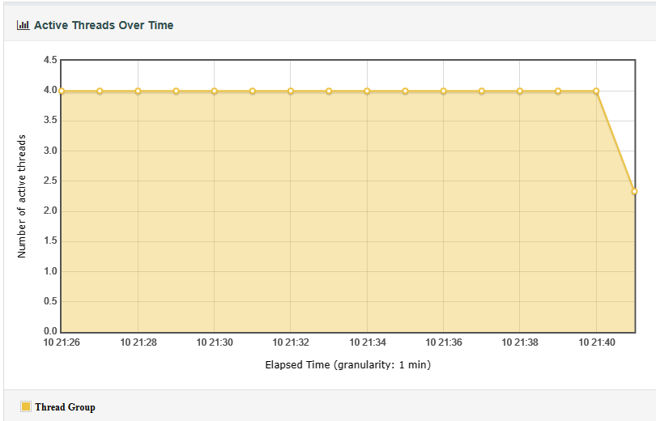

**Latency Over Time**

Note:

Need to investigate high latency to understand the high transaction response time the following transactions:

WebstaurantStoreSD

Beverage Equipment

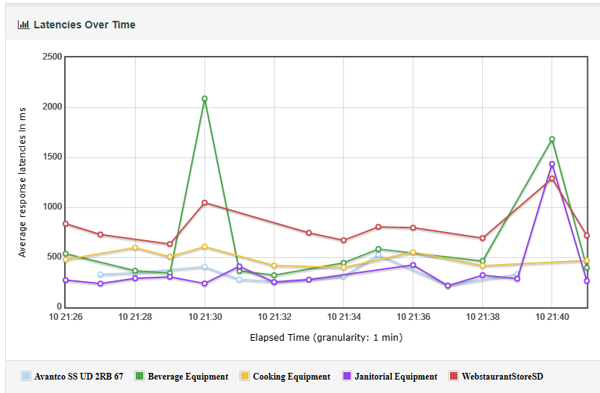

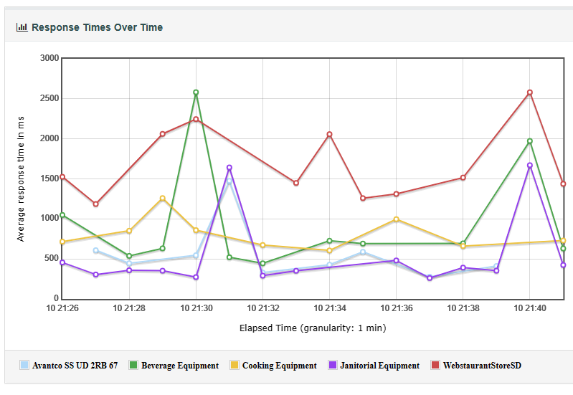

**Connect Over Time**

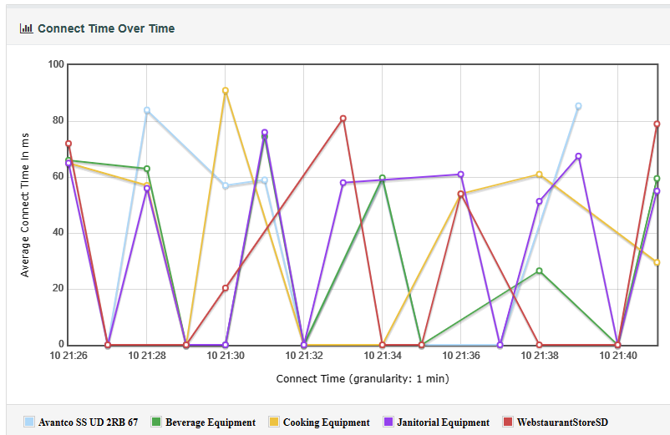

Transactions Per Second

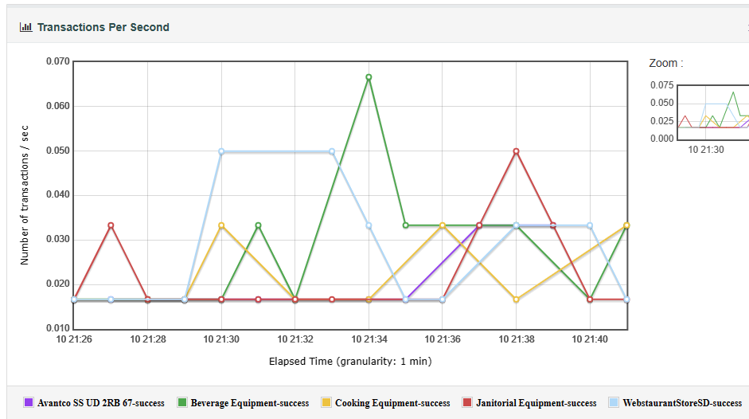

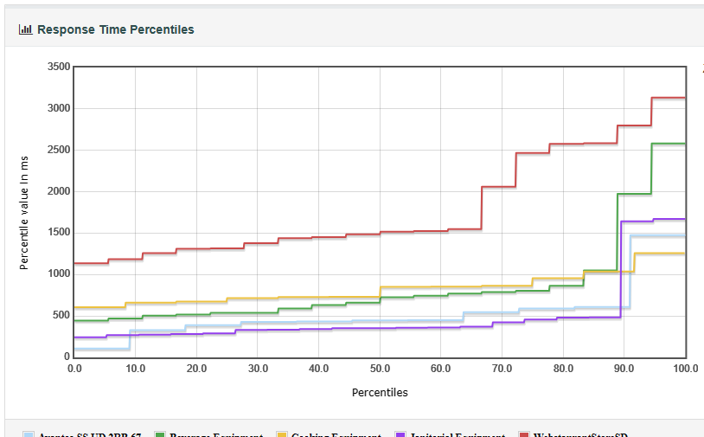

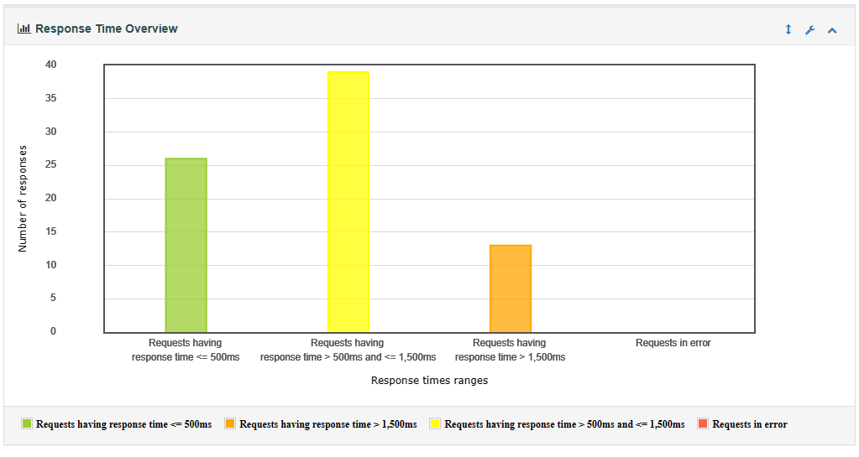

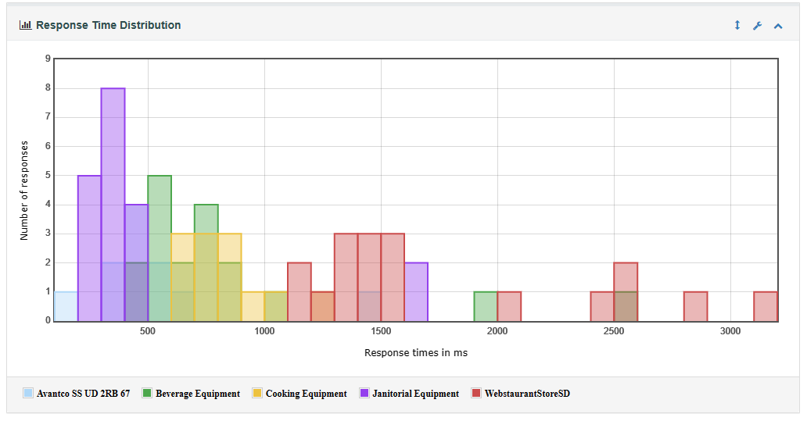

**Conclusions:**

The following transactions need to be investigated for the high transaction response time. It seems the issue may be being caused by the high server latency in the case of these transactions.

WebstaurantStoreSD (95 pct = 3.137 secs)

Beverage Equipment (95 pct = 2.583 secs)